C. Transfer to Fixed Assets

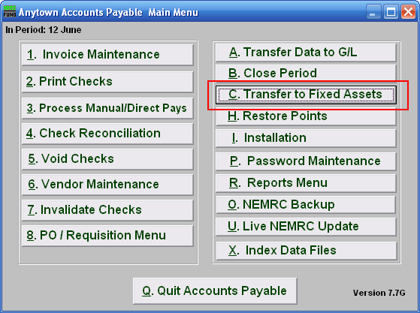
Click on “C. Transfer to Fixed Assets” from the Main Menu and the following window will appear:

Transfer to Fixed Assets

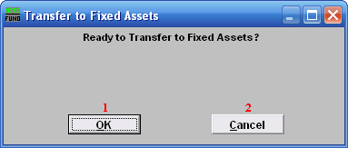
- OK: Click “OK” when you are ready to Transfer to Fixed Assets.

- Cancel: Click “Cancel” to cancel and return to the previous screen.

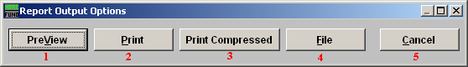
      - PreView: Click this button to preview. Refer to GENERAL PREVIEW for more information.

      - Print: Click this button to print. Refer to GENERAL PRINTING for more information.

      - Print Compressed: Click this button to print. This is different from the “Print” option in that it will use less paper for the same report.

      - File: Click this button to save on this computer. Refer to GENERAL FILE for more information.

      - Cancel: Click “Cancel” to cancel and return to the previous screen.

